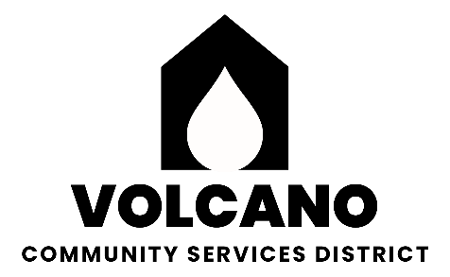

**Volcano Community Services District**

P.O. Box 72

Volcano, California 95689

**BOARD OF DIRECTORS**

REBECCA KOREMATSU (209)296-1995

PRESIDENT MIKE SORENSEN (209)296-7664

VICE PRESIDENT JOE WOLFBRANDT (209) 712-4251

ALAN KOREMATSU (916)844-9123

### **AGENDA**

##### General Meeting

#### **Thursday, March 13, 2025 •Armory Hall, Volcano • 7:00 P.M.**

In compliance with the Americans with Disabilities Act, if you are a disabled person and you need a disability related modification or accommodation to participate in this meeting, please contact Mike Sorensen at (209)296-7664. Requests must be made as early as possible and at least one-full business day before the start of the meeting. Floor discussion at board discretion will be limited to 5 minutes per subject per individual.

**CONSENT AGENDA:** Items on the consent agenda are considered routine and may be enacted by one motion. Any item may be removed for discussion and made part of the regular agenda under Agenda items at the request of a Board Member.

1. Minutes of the regular meeting of January 9, 2024

**MEETING CALLED TO ORDER:** Minutes of regular meetings are recorded on the Secretary’s computer.

**DISTRICT ENGINEER’S REPORT-** George Barnes

1. Monthly Cleveland Tunnel flow treated and untreated including diverted via black pipe.
2. Review of completed testing results for the current quarter.
3. Water Diversion Reporting 2024 – completed.
4. Electronic Annual Report System (eARs) – open 2/1/2025, due date 60 days after letter.
5. Build weir outside Cleveland Tunnel, D. Ketron and S. Schippers volunteering to help. Update on schedule to have the weir done.
6. Status of ordering extra meters to standardize meters throughout the district.
7. Any other issues, etc. to address.

**REGULAR AGENDA**

1. Vacant VCSD Board Position; Letters of Interest/Appointment of Director. M. Sorensen **ACTION**
2. Volcano Hills Community Firebreak. VCSD Support for Project. A. Korematsu **ACTION**
3. Payment of Prop. 68 Project Manager Fee. B. Stein **ACTION.**
4. VCSD Audits for 2020-21, 2021-22, 2022-23, and 2023-24. Approval to initiate finding a new auditor or stay with current auditor. R. Korematsu **ACTION**
5. VCSD Insurance Renewal. R. Korematsu **ACTION**
6. Accounting reports for Board, review and revision. R. Korematsu **ACTION**
7. Town bathrooms defensible space. M. Gottstein **ACTION**
8. Hall/Park Grant Report – B. Stein. Information
9. Meter Reading/Park – R. Zehender Information
10. Secretary’s Report – R. Korematsu Information. Statement of Financial Transaction, Board Compensation Report.
11. Hearing from those who wish to address the Board (limited to 3 minutes per person). Any person may address the Board at this time upon any subject within the jurisdiction of the Volcano Community Services District. Any matter that requires an action will be referred to the Board for a report and action at a subsequent Board Meeting.
12. Delinquent Account Collections Process and Next Steps. M. Sorensen, R. Korematsu. **ACTION (closed session)**